1. Write a program, which creates an array of 20 elements of type integer and initializes each of the elements with a value equals to the index of the element multiplied by 5. Print the elements to the console.

Array[2]=2\*5

SOLUTION:

int[] arr = new int[20];

for (int i = 0; i < arr.Length; i++)

{

arr[i] = (i + 1) \* 5;

}

foreach (int item in arr)

{

Console.WriteLine(item);

}

OUTPUT:

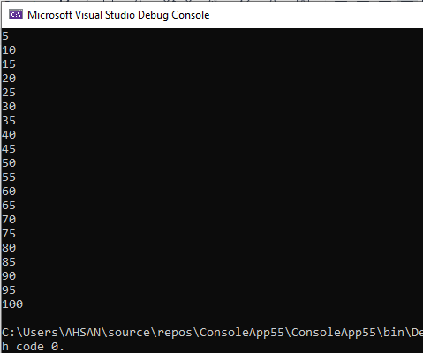

1. Write a program, which reads two arrays from the console and checks whether they are equal (two arrays are equal when they are of equal length and all of their elements, which have the same index, are equal).

Array[6]={1,1,1,2,2,9}

Array2[6]={1,1,1,2,2,2}

SOLUTION:

int n, m;

Console.Write("enter length of first array: ");

n = int.Parse(Console.ReadLine());

int[] array1 = new int[n];

for (int i = 0; i < n; i++)

{

Console.Write(" enter element no {0}: ",i+1);

array1[i] = int.Parse(Console.ReadLine());

}

Console.Write("\nenter length of second array: ");

m = int.Parse(Console.ReadLine());

int[] array2 = new int[m];

for (int j = 0; j < m; j++)

{

Console.Write(" enter element no {0}: ",j+1);

array2[j] = int.Parse(Console.ReadLine());

}

int n1 = array1.Length;

int n2 = array2.Length;

bool equal = true;

if (n1 == n2)

{

for (int i = 0; i < n; i++)

{

if (array1[i] != array2[i])

{

equal = false;

break;

}

}

}

if (equal==true)

{

Console.WriteLine("\nboth arrays are equal");

}

else

{

Console.WriteLine("\nboth arrays are not equal");

}

OUTPUT: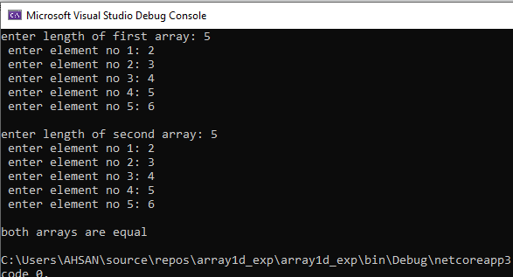

1. Make a program in C# in which take 5 numbers from user and then give sum and avg. of them. Using arrays.

SOLUTION:

int sum = 0;

double avg;

int[] arr = new int[5];

for (int i = 0; i < 5; i++)

{

Console.Write("enter {0} number: ",i+1);

arr[i] = int.Parse(Console.ReadLine());

sum += arr[i];

}

avg = sum / 5;

Console.WriteLine("\n------------------------------\n >>>>> SUM= "+sum);

Console.WriteLine(" >>>>> AVERAGE= "+avg);

OUTPUT: